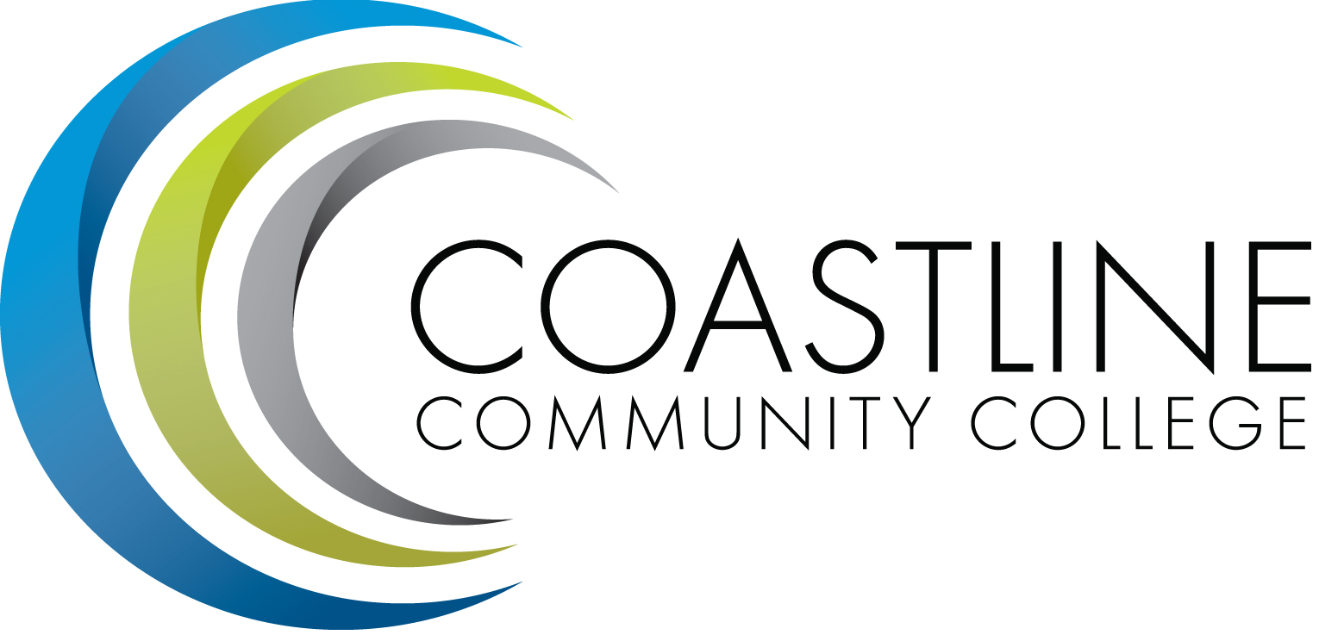

College Professional Development & Leadership Committee Agenda
11/07/2017, 3:00 pm to 5:00 pm
College Center, Distance Learning Conference Room

Committee Mandate: To promote, coordinate, recommend, and support the creation and delivery of professional development and leadership programs that increase the effectiveness of our institution and the satisfaction of our employees.

CALL TO ORDER
  - Welcome
  - Adoption of Agenda
  - Approval of Minutes: 10/03/2017

SPECIAL REPORTS
  - Atomic Learning Presentation – Leah Klocker (Higher Education Sales Consultant)

ACTION ITEMS
  - Follow up on Action Items from (10/03/2017):
3.1.1 Each member of this committee to bring one suggestion for the Strategic Plan
3.1.2 Vision Statement and Goals

STANDING REPORTS
  - FSC Update – Cheryl
  - Classified Update
  - Human Resources Update – Renate
  - Flex Update - Ann

DISCUSSION ITEMS
  - None

ANNOUNCEMENTS
  - None

ADJOURNMENT

Next Meeting: (December 5, 2017, College Center, Distance Learning Conference Room)

